INDEX
Table of Contents
1. Experiment Name: Design a Simple Webpage using only HTML tags for 'Computer Science and Engineering Department of Northern College Bangladesh' 2
Theory: 2
Source Code: 2
Results: 3
2. Experiment name: Design a simple website to navigate between different pages using text links 4
Theory: 4
Source code: 4
Result: 5
3. Experiment name: Design a simple website using CSS to format text, forms, tables, and link styles. 7
Theory: 7
Source code: 7
Result: 9
4. Experiment name: Design a website with a CSS menu to navigate between different pages 10
Theory: 10
Source code: 10
Result: 12
5. Experiment Name: Designing a Form with Text Fields, Text Area, Checkboxes, Radio Buttons, List Boxes, Password Fields, Submit Button, Reset Button, and Store the Value in MySQL Database Using PHP. 13
Theory: 13
Source Code: 13
Result: 16
6. Experiment name: Design a webpage for inputting personal information and performing input validation using JavaScript. 17
Theory: 17
Source code: 17
Result: 19

1. Experiment Name: Design a Simple Webpage using only HTML tags for 'Computer Science and Engineering Department of Northern College Bangladesh'

Theory:
The objective of this experiment is to design a simple webpage using HTML tags for the 'Computer Science and Engineering Department of Northern College Bangladesh'. The page should include the <head>, <title>, and <body> tags, as well as divisional tags like <div>, <span>, <table> as needed.

Source Code:
<!DOCTYPE html>
<html>
<head>
<title>Computer Science and Engineering Department of Northern College Bangladesh</title>
</head>
<body>

<span>Computer Science and Engineering Department</span>

<div>
<table>
<tr>
<th>Course Name</th>
<th>Course Code</th>
<th>Credit Hours</th>
</tr>
<tr>
<td>Introduction to Computer Science</td>
<td>CSE 101</td>
<td>3</td>
</tr>
<tr>
<td>Data Structures and Algorithms</td>
<td>CSE 201</td>
<td>3</td>
</tr>
<tr>
<td>Computer Networks</td>
<td>CSE 301</td>
<td>3</td>
</tr>
</table>
</div>

</body>
</html>

Results:
The above source code will generate a simple webpage for the 'Computer Science and Engineering Department of Northern College Bangladesh'. The page will include a header with the department name, a brief description, and two divisional tags. The first divisional tag will include information about the department, and the second divisional tag will include a table with the names, course codes, and credit hours for three courses offered by the department.
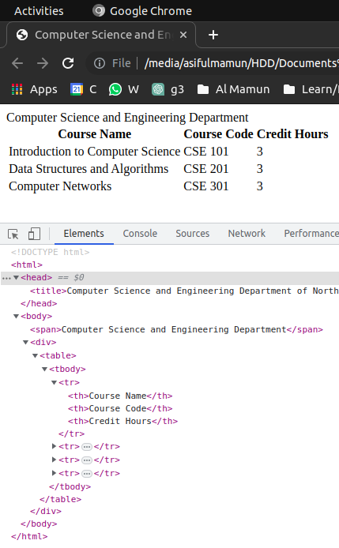

2. Experiment name: Design a simple website to navigate between different pages using text links

Theory:
The objective is to design a website with text links to navigate between different pages. The website will include a homepage and two additional pages: one with an image and one with a 2x3 table. The text links will allow the user to easily navigate between these pages.

Source code:
Homepage (index.html):
<!DOCTYPE html>
<html>
<head>
<title>My Website</title>
</head>
<body>
<h1>Welcome to my website!</h1>
<p>Click the links below to visit other pages:</p>
<ul>
<li><a href="image.html">Image</a></li>
<li><a href="table.html">Table</a></li>
</ul>
</body>
</html>
Page with image (image.html):
<!DOCTYPE html>
<html>
<head>
<title>My Website - Image</title>
</head>
<body>
<h1>Image</h1>
<p>Here is an image:</p>
<a href="index.html"><img src="https://via.placeholder.com/300" alt="placeholder"></a>
<p>Click <a href="index.html">here</a> to return to the homepage.</p>
</body>
</html>
Page with table (table.html):
<!DOCTYPE html>
<html>
<head>
<title>My Website - Table</title>
</head>
<body>
<h1>Table</h1>
<table>
<tr>
<th>Column 1</th>
<th>Column 2</th>
<th>Column 3</th>
</tr>
<tr>
<td>Row 1, Column 1</td>
<td>Row 1, Column 2</td>
<td>Row 1, Column 3</td>
</tr>
<tr>
<td>Row 2, Column 1</td>
<td>Row 2, Column 2</td>
<td>Row 2, Column 3</td>
</tr>
</table>
<p>Click <a href="index.html">here</a> to return to the homepage.</p>
</body>
</html>

Result:
When you open the index.html file in a web browser, you will see the homepage with two text links ("Image" and "Table") below the welcome message. Clicking on one of these links will take you to the corresponding page. On the image page, you will see an image with a link back to the homepage. On the table page, you will see a 2x3 table with a link back to the homepage.

Homepage (index.html):


Page with image (image.html):


Page with table (table.html):
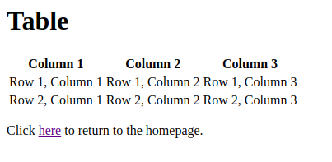

3. Experiment name: Design a simple website using CSS to format text, forms, tables, and link styles.

Theory:
The objective is to design a website that uses CSS to format text, forms, tables, and link styles. The website will include a homepage, a form page, and a table page. The CSS will be applied using all three methods: external, internal, and inline styles.

Source code:
index.html (homepage)
<!DOCTYPE html>
<html>
<head>
<title>My Website</title>
<!-- External CSS -->
<link rel="stylesheet" href="style.css">
<!-- Internal CSS -->
<style>
h1 {
color: blue;
font-size: 36px;
}
</style>
</head>
<body>
<h1>Welcome to My Website</h1>
<p>This is the homepage of my website. Here are some links:</p>

<form>
<label for="name">Name:</label>
<input type="text" id="name" name="name">
<br>
<label for="email">Email:</label>
<input type="email" id="email" name="email">
<br>
<label for="message">Message:</label>
<textarea id="message" name="message"></textarea>
<br>
<input type="submit" value="Submit">
</form>

<table>
<tr>
<th>Name</th>
<th>Age</th>
<th>Gender</th>
</tr>
<tr>
<td>John Doe</td>
<td>25</td>
<td>Male</td>
</tr>
<tr>
<td>Jane Smith</td>
<td>30</td>
<td>Female</td>
</tr>
</table>

<!-- Inline CSS -->
<p>Here's a link with inline styling: <a href="#" style="color: red;">Click me</a></p>

</body>
</html>

style.css (external style sheet)
/* External CSS style */
body {
font-family: Arial, sans-serif;
}

ul {
list-style-type: none;
margin: 0;
padding: 0;
}

li {
display: inline-block;
margin-right: 20px;
}

Result:
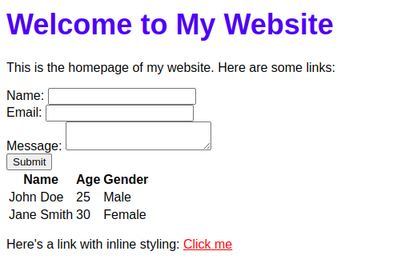

4. Experiment name: Design a website with a CSS menu to navigate between different pages

Theory:
The objective of this experiment is to design a website with a CSS menu that allows users to navigate between different pages. The website should have a minimum of three pages, and each page should contain a heading, paragraph, text formatting tags, and mouse-over links to go back to the homepage. The menu should be designed using CSS to create a professional and cohesive look across all pages.

Source code:
index.html:
<!DOCTYPE html>
<html>
<head>
<meta charset="UTF-8">
<title>My Website</title>
<link rel="stylesheet" href="style.css">
</head>
<body>
<nav>
<ul>
<li><a href="#">Home</a></li>
<li><a href="page2.html">Page 2</a></li>
<li><a href="page3.html">Page 3</a></li>
</ul>
</nav>
<h1>Welcome to my website</h1>
<p>Lorem ipsum dolor sit amet, consectetur adipiscing elit. Donec sed lectus in enim malesuada tempus.</p>
</body>
</html>
page2.html:
<!DOCTYPE html>
<html>
<head>
<meta charset="UTF-8">
<title>My Website - Page 2</title>
<link rel="stylesheet" href="style.css">
</head>
<body>
<nav>
<ul>
<li><a href="index.html">Home</a></li>
<li><a href="#">Page 2</a></li>
<li><a href="page3.html">Page 3</a></li>
</ul>
</nav>
<h1>Page 2</h1>
<p>Lorem ipsum dolor sit amet, consectetur adipiscing elit. Vestibulum euismod, lorem ac iaculis fermentum, orci ex tristique magna, id tincidunt ante nisi a ante.</p>
</body>
</html>
page3.html:
<!DOCTYPE html>
<html>
<head>
<meta charset="UTF-8">
<title>My Website - Page 3</title>
<link rel="stylesheet" href="style.css">
</head>
<body>
<nav>
<ul>
<li><a href="index.html">Home</a></li>
<li><a href="page2.html">Page 2</a></li>
<li><a href="#">Page 3</a></li>
</ul>
</nav>
<h1>Page 3</h1>
<p>Lorem ipsum dolor sit amet, consectetur adipiscing elit. Aliquam rutrum neque eu convallis mattis. Nam gravida eget nibh eget malesuada.</p>
</body>
</html>
style.css:
nav {
background-color: #333;
color: #fff;
padding: 10px;
}

nav ul {
list-style: none;
margin: 0;
padding: 0;
}

nav li {
display: inline-block;
margin-right: 10px;
}

nav a {
color: #fff;
text-decoration: none;
}

nav a:hover {
color: #ff0;
}

Result:
A website with a professional and cohesive design, featuring a CSS menu that allows users to navigate between different pages. Each page contains a heading, paragraph, text formatting tags, and mouse-over links to go back to the homepage. The website has a modern look and feel and is easy to use
index.html:

page2.html:

page3.html:


5. Experiment Name: Designing a Form with Text Fields, Text Area, Checkboxes, Radio Buttons, List Boxes, Password Fields, Submit Button, Reset Button, and Store the Value in MySQL Database Using PHP.

Theory:
A form is a vital element of any website or application that collects data from users. It is an interactive component of a website that allows users to enter and submit data. The form collects data through different form elements such as text fields, text area, checkboxes, radio buttons, list boxes, password fields, etc.
To create a form that stores data in a MySQL database using PHP, we need to follow some steps:
- Design a form using HTML that contains different form elements as per the requirement.
- Add the necessary attributes to each form element such as name, value, type, etc., which help identify the form elements.
- Write a PHP script that processes the form data and inserts it into a MySQL database.
- Create a connection with the MySQL database using PHP's built-in functions such as mysqli_connect().
- Create a table in the MySQL database where we can store the form data.
- Define the SQL statement to insert data into the table.
- Execute the SQL statement using mysqli_query() function.
- Finally, display the stored data in another page using PHP.

Source Code:
The source code for creating a form with different form elements and storing the data in a MySQL database using PHP is as follows:
HTML Form Code:
<!DOCTYPE html>
<html>
<head>
<title>Form Design</title>
</head>
<body>
<h1>My Form</h1>
<form action="store_data.php" method="post">
<label for="name">Name:</label>
<input type="text" id="name" name="name" required><br><br>
<label for="email">Email:</label>
<input type="email" id="email" name="email" required><br><br>
<label for="password">Password:</label>
<input type="password" id="password" name="password" required><br><br>
<label for="gender">Gender:</label>
<input type="radio" id="male" name="gender" value="male" required>
<label for="male">Male</label>
<input type="radio" id="female" name="gender" value="female" required>
<label for="female">Female</label><br><br>
<label for="country">Country:</label>
<select id="country" name="country" required>
<option value="">Select a country</option>
<option value="India">India</option>
<option value="USA">USA</option>
<option value="UK">UK</option>
<option value="Canada">Canada</option>
</select><br><br>
<label for="interest">Interests:</label><br>
<input type="checkbox" id="interest1" name="interest[]" value="music">
<label for="interest1">Music</label>
<input type="checkbox" id="interest2" name="interest[]" value="sports">
<label for="interest2">Sports</label>
<input type="checkbox" id="interest3" name="interest[]" value="books">
<label for="interest3">Books</label><br><br>
<label for="comments">Comments:</label><br>
<textarea id="comments" name="comments"></textarea><br><br>
<input type="submit" value="Submit">
<input type="reset" value="Reset">
</form>
</body>
</html>
store_data.php
<?php
// Establishing a connection with MySQL database
$host = "localhost";
$user = "root";
$password = "";
$dbname = "mydatabase";

$conn = mysqli_connect($host, $user, $password, $dbname);
if (!$conn) {
die("Connection failed: " . mysqli_connect_error());
}

// Processing form dastore_data.phpta and inserting it into MySQL database
$name = $_POST["name"];
$email = $_POST["email"];
$password = $_POST["password"];
$gender = $_POST["gender"];
$country = $_POST["country"];
$interests = implode(", ", $_POST["interest"]);
$comments = $_POST["comments"];

$sql = "INSERT INTO formdata (name, email, password, gender, country, interests, comments)
VALUES ('$name', '$email', '$password', '$gender', '$country', '$interests', '$comments')";

if (mysqli_query($conn, $sql)) {
echo "Form data stored successfully.";
} else {
echo "Error: " . $sql . "<br>" . mysqli_error($conn);
}

mysqli_close($conn);
?>
store_data.php
<!-- Displaying the stored data in another page using PHP -->
<!DOCTYPE html>
<html>
<head>
<title>Form Data</title>
</head>
<body>
<h1>Form Data</h1>
<?php
$conn = mysqli_connect($host, $user, $password, $dbname);
if (!$conn) {
die("Connection failed: " . mysqli_connect_error());
}

$sql = "SELECT * FROM formdata";
$result = mysqli_query($conn, $sql);

if (mysqli_num_rows($result) > 0) {
while ($row = mysqli_fetch_assoc($result)) {
echo "Name: " . $row["name"] . "<br>";
echo "Email: " . $row["email"] . "<br>";
echo "Gender: " . $row["gender"] . "<br>";
echo "Country: " . $row["country"] . "<br>";
echo "Interests: " . $row["interests"] . "<br>";
echo "Comments: " . $row["comments"] . "<br><br>";
}
} else {
echo "No data found.";
}

mysqli_close($conn);
?>
</body>
</html>

Result:
Index.html
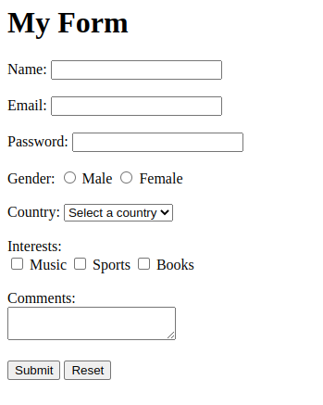

store_data.php
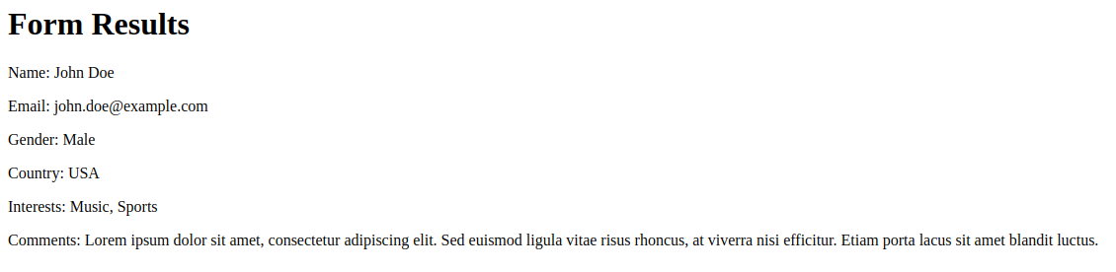

6. Experiment name: Design a webpage for inputting personal information and performing input validation using JavaScript.

Theory:
In web development, form validation is a crucial step to ensure that the data entered by the user is accurate and meets certain criteria. JavaScript is a client-side scripting language that can be used for validating form data before submitting it to the server.
The basic idea behind form validation using JavaScript is to check the input data against a set of predefined rules to make sure it is valid. These rules can be used to ensure that mandatory fields are filled out, email addresses are in a valid format, phone numbers are in the correct format, and so on.
To perform input validation using JavaScript, we need to use a combination of HTML and JavaScript. We create an HTML form with input fields for the required information and attach JavaScript code to the form's submit button. When the user submits the form, the JavaScript code is executed, and the input data is validated. If any of the validation checks fail, an error message is displayed, and the form is not submitted.

Source code:
Here is an example of a webpage that allows users to input personal information and performs input validation using JavaScript.
<!DOCTYPE html>
<html>
<head>
<title>Input Validation using JavaScript</title>
<script>
function validateForm() {
var name = document.forms["myForm"]["name"].value;
var address = document.forms["myForm"]["address"].value;
var email = document.forms["myForm"]["email"].value;
var gender = document.forms["myForm"]["gender"].value;
var mobile = document.forms["myForm"]["mobile"].value;

// Check if all mandatory fields are filled out
if (name == "" || address == "" || email == "" || gender == "" || mobile == "") {
alert("Please fill out all mandatory fields.");
return false;
}

// Check if email address is in a valid format
var emailRegex = /^\w+([\.-]?\w+)*@\w+([\.-]?\w+)*(\.\w{2,3})+$/;
if (!emailRegex.test(email)) {
alert("Please enter a valid email address.");
return false;
}

// Check if mobile number is in a valid format (11 digits)
var mobileRegex = /^01\d{9}$/;
if (!mobileRegex.test(mobile)) {
alert("Please enter a valid mobile number (11 digits).");
return false;
}

// If all checks pass, submit the form
return true;
}
</script>
</head>
<body>
<form name="myForm" onsubmit="return validateForm()" method="post">
<label for="name">Name:</label>
<input type="text" id="name" name="name" required><br><br>

<label for="address">Address:</label>
<textarea id="address" name="address" required></textarea><br><br>

<label for="email">Email:</label>
<input type="email" id="email" name="email" required><br><br>

<label for="gender">Gender:</label>
<input type="radio" id="male" name="gender" value="male" required>
<label for="male">Male</label>
<input type="radio" id="female" name="gender" value="female">
<label for="female">Female</label><br><br>

<label for="mobile">Mobile:</label>
<input type="text" id="mobile" name="mobile" pattern="01[3-9][0-9]{8}" required><br><br>

<input type="submit" value="Submit">
</form>
</body>
</html>

Result:
There showing email validation only, other’s validation also working.
